Kinematic Analysis Script Standard Operating Procedure
Inputs:  - Segmented Volumes (.tiff)  - Bone Models (.stl)  - Tracking files (.tra)  - Local Coordinate systems from AAFACT(.txt)  Outputs:  - RSA Comparison  - Joint Angles  - Bone kinematics  - Visualized Data  - Proximity Maps | 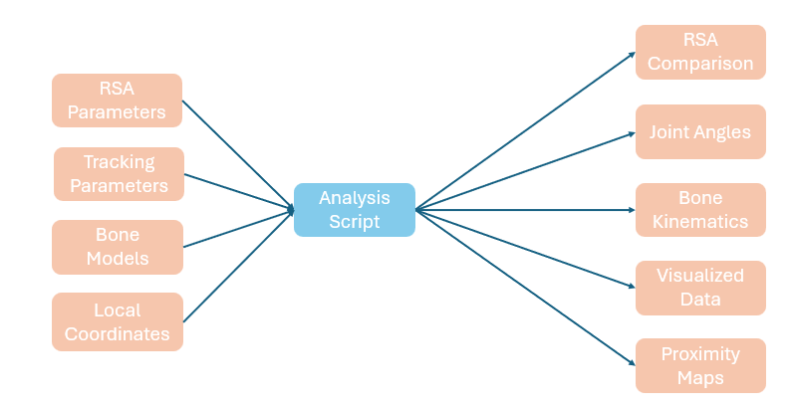
Janae edits: 19Sep25
MATLAB Addons to download before running code:
Download Computer Vison Toolbox --> for the “vectarrow” function
Download Signal Processing Toolbox --> for the “butter” filter
Download Robotics System Toolbox --> for the “rot2eul” function
Find them here:
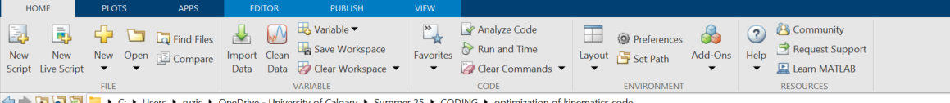
The custom functions required to run this code are listed below. See the following instructions for the purpose, inputs, and outputs of each function.
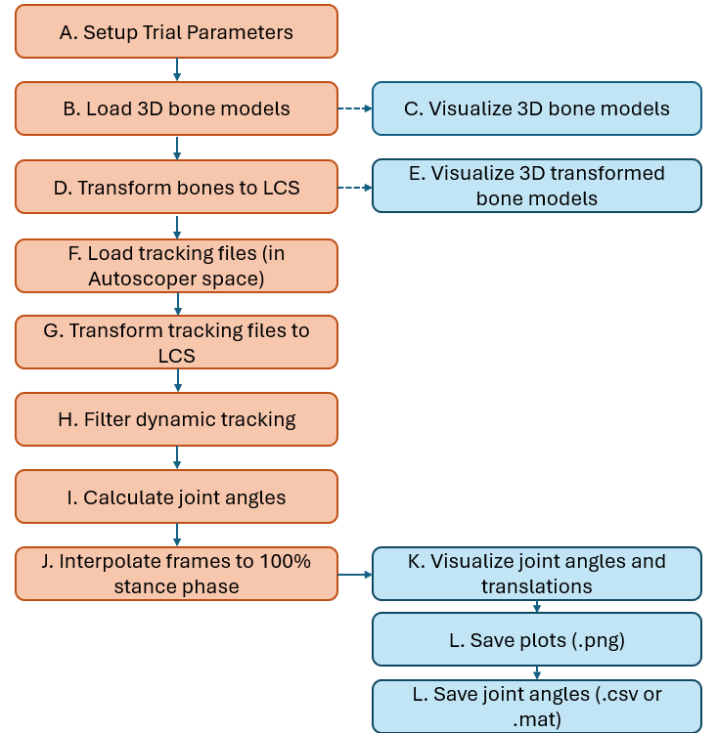

Function usage and summaries

SetupTrialParameters.m
function [folderPath, trialNumStr, prefix, side, resultsFolder, jointSelection, cutoff_freq, sampling_freq, heelStrikeFrame, toeOffFrame, numFrames, gaitCycle] = SetupTrialParameters ()

PURPOSE: Guides the user through selecting a trial folder and entering trial parameters. Returns all relevant variables for processing the trial.
- When setup successful, the function will alert you and list the trial you selected.

OUTPUTS:
- folderPath: string, path to the selected trial folder
- trialNumStr: string, trial number extracted from folder name
- prefix: string, trial type (e.g., 'Walking')
- side: string, side ('R' or 'L')
- resultsFolder: string, path to the results folder
- jointSelection: integer, selection of joints to analyze
- cutoff_freq: double, desired cutoff frequency in Hz
- sampling_freq: double, sampling frequency in Hz
- heelStrikeFrame: double, frame number of heel strike
- toeOffFrame: double, frame number of toe off
- numFrames: double, number of frames between heel strike and toe off
- gaitCycle: struct, stores heel strike and toe off frames

Expected output for the results folder:
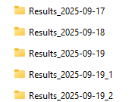

BuildBoneModels.m
function [Bone_model, Bone_model_Auto, Coordinate, LCS2Auto, LCS_Auto] = BuildBoneModels (folderPath, jointSelection)

PURPOSE: Loads 3D bone models (STL files) and their anatomical coordinate systems from a folder. Computes local coordinate system (LCS) transformations for each bone, preparing to be applied in Transform2LCS

INPUTS:
- folderPath: string – path to the folder that is selected in part A Contains the bone models and CS files
- jointSelection: integer – determines which bones/joints to load based on the input provided in part A.
    - 1 = Tibia & Talus only
    - 2 = Calcaneus / Subtalar joint
    - 3 = Midfoot joint (Navicular & Cuboid)

OUTPUTS
- Bone_model: loaded STL bone model (raw points)
- Bone_model_Auto: Bone models with points augmented for homogeneous coordinates
- Coordinate: Loaded anatomical coordinate systems for each bone/joint
- LCS2AUTO: Homogeneous transformation matrices from local to automatic coordinates
- LCS_Auto: Origin and unit vectors (X, Y, Z) for each bone's local coordinate system

Visualize 3D bone models
Expected output:
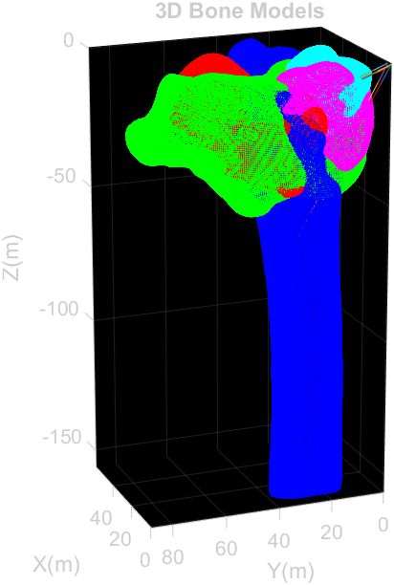

LocalCoordinates.m
function [R_Matx, new_origin, x_axis_unit, y_axis_unit, z_axis_unit] = LocalCoordinates (points)

PURPOSE: Defines a local coordinate system (LCS) for a bone or object based on four input points: one origin and three points defining the X, Y, Z axes. Returns a 4x4 homogeneous transformation matrix, the origin coordinates, and unit vectors along each axis.

INPUTS:
- points: [4x3 double], Coordinates defining the local coordinate system:
row 1 = origin
row 2 = point along the Y axis
row 3 = point along the Z axis
row 4 = point along the X axis

OUTPUTS:
- R_Matx: [4x4 double] Homogeneous transformation matrix representing rotation and translation from local to global coordinates
- new_origin: [1x3 double] Coordinates of the new origin
- x_axis_unit: [1x3 double] Unit vector along the X axis
- y_axis_unit: [1x3 double] Unit vector along the Y axis
- z_axis_unit: [1x3 double] Unit vector along the Z axis

Transform2LCS.m
PURPOSE: Transforms 3D bone points and coordinate system axes from Auto coordinates to each bone's Local Coordinate System (LCS). Only bones specified by jointSelection are processed. Axis transformation is only performed if available in LCS_Auto.
INPUTS:
Bone_model: struct with original bone points (e.g., Bone_model.Tibia)
LCS2Auto: struct with transformation matrices from LCS to Auto
LCS_Auto: struct with origin and axes (X,Y,Z) for each bone/joint
jointSelection: integer
1 = Tibia & Talus
2 = + Calcaneus/Subtalar
3 = + Midfoot joints (Navicular & Cuboid)
OUTPUTS:
      - Bone_model_LCS: struct with transformed bone points
      - LCS_LCS: struct with transformed origin and axes (if available)
      - Auto2LCS: struct with inverse transformation matrices

Visualize 3D bone models with LCS applied and aligned to the origin
Expected output:
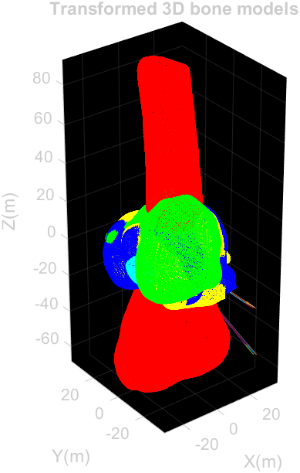

LoadTRA.m
PURPOSE: Loads dynamic and neutral bone tracking data from .tra files for a given trial, side, and set of bones defined by jointSelection. Converts each frame into a 4×4 homogeneous transformation matrix, interpolates missing values (NaNs), and records the number of frames and starting frames for each bone.

INPUTS:
- trialNumStr (string) – Trial number as a string (e.g., '01').
- side (string) – Side of the subject ('L' or 'R').
- folderName (string) – Name of the folder containing tracking data for the trial.
- folderPath (string) – Path to the parent folder where trial folders are located.
- prefix (string) – Field name prefix used to organize structures (e.g., 'Trial01').
- jointSelection (integer) – Determines which bones to load:
  - 1 = Tibia & Talus
  - 2 = + Calcaneus
  - 3 = + Midfoot joints (Navicular & Cuboid)

OUTPUTS:
a. Tracking_Auto (struct) – 4×4×N tracking matrices for each bone in the Auto coordinate system.
b. Neutral_Auto (struct) – 4×4 matrices representing the neutral (reference) position for each bone.
c. Tracking_Data (struct) – Raw .tra file contents for both dynamic and neutral trials.
d. trackingFolder (string) – Full path to the folder where dynamic tracking files are located.
e. Lengths (struct) – Number of frames for each bone’s tracking data.
f. Starts (struct) – First non-NaN frame index for each bone.

TransformTracking.m
PURPOSE:
Transforms neutral and dynamic bone tracking matrices from the global Auto coordinate system to each bone’s Local Coordinate System (LCS). For each bone, the function outputs the transformed homogeneous matrices, Euler angles (XYZ or YXZ convention), and translations. The set of joints processed depends on jointSelection.

INPUTS:
- Neutral_Auto (struct) – Neutral tracking matrices in the Auto coordinate system for each bone.
- Tracking_Auto (struct) – Dynamic tracking matrices in the Auto coordinate system for each bone.
- Auto2LCS (struct) – Transformation matrices from Auto → LCS for each bone/joint.
- Lengths (struct) – Number of frames for each bone’s tracking data.
- prefix (string) – Field name prefix used to organize output structures.
- jointSelection (integer) – Determines which bones/joints are transformed:
  - 1 = Tibiotalar joint (Tibia & Talus)
  - 2 = + Subtalar joint (Calcaneus & Talus)
  - 3 = + Talonavicular (Talus & Navicular)
  - 4 = + Calcaneocuboid (Calcaneus & Cuboid)

OUTPUTS:
a. Neutral_matx_LCS (struct) – Neutral 4×4 transformation matrices in LCS for each bone/joint.
b. Tracking_LCS (struct) – Dynamic 4×4 transformation matrices in LCS for each bone/joint across all frames.
c. Angle_LCS (struct) – Joint Euler angles (XYZ sequence, in degrees) per frame for each bone/joint.
d. Translation_LCS (struct) – Joint translations (x, y, z in mm) per frame for each bone/joint.

FilterTracking.m
PURPOSE:
Applies a 4th-order Butterworth low-pass filter to bone tracking data in the Local Coordinate System (LCS). Each element of the 4×4×N tracking matrices is filtered independently along the time dimension.
Only the bones specified by jointSelection are processed.

INPUTS:
- Tracking_LCS (struct) – Raw (unfiltered) dynamic bone tracking data in LCS.
- prefix (string) – Field name prefix used to organize structures (e.g., 'Trial01').
- cutoff_freq (double) – Cutoff frequency of the low-pass filter (Hz).
- sampling_freq (double) – Sampling frequency of the tracking data (Hz).
- jointSelection (integer) – Determines which bones/joints are filtered:
  - 1 = Tibiotalar joint (Tibia & Talus)
  - 2 = + Subtalar joint (Calcaneus & Talus)
  - 3 = + Talonavicular (Talus & Navicular)
  - 4 = + Calcaneocuboid (Calcaneus & Cuboid)

OUTPUTS:
a. Filtered_Tracking_LCS (struct) – Filtered 4×4×N transformation matrices for each processed bone/joint, with the same structure as Tracking_LCS.

Produce Results Joint angles
Calculate joint angles by
- Calculate the transformation matrices relative to the neutral
- Apply the transformation from one bone to the other
** using the “\” operator: A\B = inv(A)*B; where A should be the proximal bone and B should be the distal bone
Example calculation for the Tibiotalar joint angle:
- Normalize the dynamic trial to the neutral:
$$\left[T_{Norm_Tibia}\right]= {\left[T_{Neutral_Tibia}\right]}^{-1}\left[T_{Dynamic_Tibia}\right]$$
$$\left[T_{Talus\sim neutral}\right]= {\left[T_{Neutral_Talus}\right]}^{-1}\left[T_{Dynamic_Talus}\right]$$
- Want the movement of the talus relative to the tibia in LCS
$$\left[T_{Norma_Talus}\right]= {\left[T_{Norm_Tibia}\right]}^{-1}\left[T_{Norm_Talus}\right]$$

InterpJointData.m
PURPOSE:
Interpolates joint angle and translation data to normalize each stance phase to 101 points (0–100%).
Ensures that all joint data is aligned to the same normalized stance phase for comparison across trials.
Only joints specified by jointSelection are processed.

INPUTS:
- Filtered_RelAngle_LCS (struct) – Relative joint angles in LCS for each joint.
- Filtered_RelTran_LCS (struct) – Relative joint translations in LCS for each joint.
- prefix (string) – Field name prefix used to organize structures (e.g., 'Trial01').
- heelStrikeFrame (integer) – Frame index of heel strike (start of stance).
- toeOffFrame (integer) – Frame index of toe off (end of stance).
- jointSelection (integer) – Determines which joints are normalized:
  - 1 = Tibiotalar joint (Tibia & Talus)
  - 2 = + Subtalar joint (Calcaneus & Talus)
  - 3 = + Talonavicular (Talus & Navicular)
  - 4 = + Calcaneocuboid (Calcaneus & Cuboid)

OUTPUTS:
a. Filtered_RelAngle_LCS_Norm (struct) – Normalized joint angles (interpolated to 101 points).
b. Filtered_RelTran_LCS_Norm (struct) – Normalized joint translations (interpolated to 101 points).

Plot results
This section plots the joint angles on separate plots, processing the joints selection as per jointSelection, and saves them to the respective results folder.
